**Cargo Management System**

**Go-VYA**

*A Project Report Submitted*

*to*

**MANIPAL ACADEMY OF HIGHER EDUCATION**

*For Partial Fulfillment of the Requirement for the*

*Award of the Degree*

*Of*

**Bachelor of Technology**

*in*

**Computer and Communication Engineering**

*by*

**Ashwin Mittal, Yogesh Rane, Vansh Yadav**

**Reg. No. 220953128,220953290, 220953306**

*Under the guidance of*

Mr. Akshay K C (Lab Faculty 1) Mrs. Swathi B P (Lab faculty 2)

Assistant Professor – Senior Scale Assistant Professor –Senior Scale

Department of I&CT Department of I&CT

Manipal Institute of Technology Manipal Institute of Technology

Manipal, Karnataka, India Manipal, Karnataka, India

**March 2024**

**ABSTRACT**

In the dynamic realm of logistics, the "Cargo Management Software" emerges as a transformative solution, bridging the gap between customers and Packing and Moving companies. By meticulously organizing essential data streams – including customer registrations, orders, and delivery services – the software fosters a dynamic ecosystem where accessibility, efficiency, and reliability converge seamlessly.

A key pillar of the "Cargo Management Software" is its robust security infrastructure, employing advanced protocols to safeguard sensitive information and uphold data integrity. This commitment to security instills trust among users and solidifies the software's reputation for reliability and integrity in cargo management.

Furthermore, the software's backend architecture, powered by a sophisticated Database Management System (DBMS), optimizes data processes, ensuring unparalleled efficiency, scalability, and reliability. This integration of advanced technology with industry-leading database practices empowers the software to navigate modern cargo logistics with ease, driving innovation and efficiency.

In conclusion, the "Cargo Management Software" represents a significant leap in logistics management, offering a comprehensive solution that redefines industry standards. As businesses and customers embrace this innovative platform, the future of cargo transportation is poised for unprecedented levels of efficiency and reliability.

**ACM Taxonomy:**

**[Security and Privacy]:** Prevention from Path Traversal Attack; Prevention from SQL Injection; Access Control.

**[Information Systems]:** Online Information Services.

**[Software and Its Engineering]:** Software Maintenance; Software Management; Software Verification and Validation; Software Testing and Debugging.

**[Data Management Systems]**: Database Management System (DBMS).

**Sustainable Development Goal (SDG):**

**[SDG]:** Sustainable Cities and Communities

**Table of Contents**

1. List of tables
2. List of Figures
3. Abbreviations
4. Chapters:
   1. Introduction -
   2. Literature Survey / Background
   3. Objectives/Problem Statement
   4. Data design (ER Diagram, Reduction, Schema Diagram, Normalization with suitable justifications)
   5. Methodology (Implementation Details with block diagram to explain the project in detail. Do not put code here.)
   6. Results
   7. Conclusion and Future Work
5. References

**List of Tables**

1. **USER** ( user_ID , name, password, email);
2. **Customer** ( c_ID , c_homeaddr, c_phoneNo);
3. **Provider** ( p_ID, p_scale, p_officeaddr, p_phoneNo, p_multiplier, p_PAN, p_GST,verified);
4. **Admin** ( adm_ID , adm_join_date);
5. **Requests** ( req_ID , c_ID, req_weight, req_size, req_speed, req_dist, req_type,start,end);
6. **Quotes** ( quote_ID , p_ID,quote_amt, quote_speed,req_id);
7. **Orders** ( order_ID , c_ID , p_ID , weight, size, type, speed,bill,start,end, status, dist)
8. **Employee** ( emp_ID , emp_email, emp_salary );
9. **Emp_PhoneNo** ( emp_ID, emp_phoneNo );

**List of Figures**

**Figure 1 ER Diagram for Go-VYA Cargo Management Service**

**Figure 2 Schema Diagram for Go-VYA Cargo Management Service**

**Figure 3 Block Diagram for Methodology for Go-VYA Cargo Management Service**

**Figure 4 Home page**

**Figure 5 New User Registration Page**

**Figure 6 Customer Registration**

**Figure 7 Provider Registration**

**Figure 8 Login Page**

**Figure 9 Wrong User ID or Password**

**Figure 10 Admin Portal**

**Figure 11 Verification of Provider Accounts**

**Figure 12 All Orders Page**

**Figure 13 Employee Details**

**Figure 14 Customer Dashboard**

**Figure 15 Customer Profile Page**

**Figure 16 New Request Creation**

**Figure 17 Asking Assistance from an Employee**

**Figure 18 Order in Progress Page**

**Figure 19 Viewing Previously Completed Orders**

**Figure 20 Provider Dashboard**

**Figure 21 Provider Profile Page**

**Figure 22 View Available Requests**

**Figure 23 Available Quotes to a Customer**

**Figure 24 Orders in Progress as Viewed by Customers**

**Figure 25 Updating Status of Orders by Provider**

**Figure 26 Unauthorized Access Page while to access resources without Permissions**

**Chapter 1**

**Introduction**

In a world with increasing dis-connectivity and demand for fast seamless shipping of items of all scales and sizes, an awkward vacuum has developed where we found way too many individual logistics providers to provide services, more often than not having a monopoly over one or more of the requirements on the shipping orders. There arises a need of a **logistics manager**, which takes into account multiple providers and their characteristics, and cater to the customer’s needs. **GO-VYA** helps provide a marketplace to connect consumers and logistics solutions providers, providing seamless quotes and order processing, ensuring efficient cheap transport solutions with respect to all the customers needs.

**Effective Innovations of GO-VYA**

* Robust Web Security Measures: Prioritizing user safety, GO-VYA fortifies its database with CSRF tokens to thwart path attacks, while employing tuple checking to safeguard against SQL injections. By proactively addressing web vulnerabilities, GO-VYA maintains the integrity of its platform, fostering trust among users.The website is also immune to path traversal attacks.
* Algorithmic Optimization for Cost-Effective Solutions: GO-VYA's backend integrates sophisticated algorithms to strike an optimal balance between cost and requirements. By meticulously aligning customer needs with provider offerings and generated quotes, GO-VYA empowers users to make informed decisions, selecting the most suitable option for their specific requirements.
* Intuitive User Interface: GO-VYA's graphical user interface (GUI) stands out for its simplicity and informativeness. Facilitating seamless communication between customers and providers, the GUI simplifies the exchange of deliverables and requirements. Additionally, real-time synchronization ensures that changes made by different users on the same order are promptly reflected, guaranteeing coherence and dynamic updates throughout the process.
* Efficient Order Tracking: GO-VYA offers customers real-time visibility into the status of their orders. From pickup to delivery, users can monitor the progress of their shipments, ensuring peace of mind and timely management of logistics.
* Seamless User Onboarding and Role Differentiation: GO-VYA boasts a user-friendly interface for effortless registration and verification, distinguishing between customers and providers with precision. GO-VYA ensures a smooth experience, delineating roles based on various attributes.

**Chapter 2**

**Literature Survey**

To learn about the elements of the project, including database management, cargo and logistics, and web development with HTML/CSS frontend and Flask backend, consider exploring the following resources:

1. Database Management:
   * "Database System Concepts" by Abraham Silberschatz, Henry F. Korth, and S. Sudarshan: A comprehensive textbook covering fundamental concepts in database management systems.
   * "SQL for Beginners: Learn SQL using MySQL and Database Design" by Nathan Clark: A beginner-friendly guide to SQL and database design principles.
   * Online resources such as W3Schools (https://www.w3schools.com/sql/) and SQLZoo (<https://sqlzoo.net/>) offer interactive tutorials and exercises for learning SQL.
2. Cargo and Logistics:
   * "Introduction to Logistics Systems Management" by Gianpaolo Ghiani, Gilbert Laporte, and Roberto Musmanno: Provides an overview of logistics systems management, including transportation, inventory management, and supply chain optimization.
   * "Logistics and Supply Chain Management" by Martin Christopher: Covers key concepts and strategies in logistics and supply chain management, including transportation modes, warehousing, and distribution networks.
   * Academic journals such as the International Journal of Logistics Management and the Journal of Business Logistics publish research articles on various topics related to logistics and supply chain management.
3. Web Development with Flask:
   * "Flask Web Development: Developing Web Applications with Python" by Miguel Grinberg: Offers a comprehensive guide to building web applications with Flask, covering topics such as routing, templates, forms, and database integration.
   * Official Flask documentation (https://flask.palletsprojects.com/en/2.1.x/): Provides detailed documentation and tutorials for learning Flask framework features and best practices.
   * Online tutorials and courses on platforms like Udemy (<https://www.udemy.com/>) and Coursera (<https://www.coursera.org/>) offer hands-on guidance for developing web applications with Flask.
4. HTML/CSS Frontend Development:
   * "HTML and CSS: Design and Build Websites" by Jon Duckett: A beginner-friendly guide to HTML and CSS, covering essential concepts and techniques for building responsive web pages.
   * Mozilla Developer Network (MDN) Web Docs (<https://developer.mozilla.org/en-US/docs/Web>): Offers comprehensive documentation and tutorials on HTML, CSS, and web development best practices.
   * Online code playgrounds like CodePen (<https://codepen.io/>) and JSFiddle (<https://jsfiddle.net/>) provide interactive environments for experimenting with HTML and CSS code.

**Chapter 3**

**Problem Statement**

In today's rapidly evolving logistics landscape, the need for an efficient and user-friendly cargo and logistics management system is paramount. With the increasing demand for seamless shipping solutions, there arises a critical necessity for a comprehensive platform that caters to the needs of customers, providers, and administrators alike.

The existing challenges within the logistics industry include disjointed communication channels, lack of transparency in the quoting process, and inefficient order management systems. These obstacles often result in delays, misunderstandings, and suboptimal decision-making, leading to decreased customer satisfaction and operational inefficiencies.

To address these issues, the proposed cargo and logistics management application, named GO-VYA, aims to streamline the shipping process by providing a centralized platform for customers to request shipments, receive quotes from providers, and select the most suitable option based on cost and time considerations.

## Why is GO-VYA needed

In today's fragmented logistics landscape, GO-VYA serves as a vital solution to unify disparate services and streamline the shipping process. By connecting customers and providers seamlessly, it offers a centralized platform for efficient quoting, order management, and real-time tracking. GO-VYA addresses the industry's need for transparency, cost-effectiveness, and convenience, making it an essential tool for businesses navigating the complexities of modern logistics

## Problem Solving

Problem Solving Approach of GO-VYA:

1. Centralized Platform: GO-VYA consolidates the fragmented logistics landscape by providing a centralized platform where customers and providers can interact, reducing the need for multiple disjointed systems.
2. Transparent Quoting Process: By offering a transparent quoting process, GO-VYA eliminates ambiguity and promotes fair competition among providers, ensuring customers receive competitive pricing for their shipments.
3. Efficient Order Management: With robust order management features, GO-VYA streamlines the shipping process, enabling customers to track their orders in real-time and providers to manage deliveries efficiently.
4. Cost-Effective Solutions: GO-VYA employs algorithms to optimize the cost-to-requirements trade-off, helping customers select the most cost-effective shipping options tailored to their specific needs.
5. Enhanced Security Measures: Through the implementation of CSRF tokens and tuple checking, GO-VYA addresses web vulnerabilities, safeguarding user data and ensuring a secure platform for transactions.
6. User-Friendly Interface: With a simple yet informative GUI, GO-VYA promotes ease of use and accessibility for both customers and providers, facilitating seamless communication and interaction.
7. **Consistent status updating mechanism:** GO-VYA provides consistent updation of values and order status at each step.

**Chapter 4**

**Database Design**

**ER Diagram**

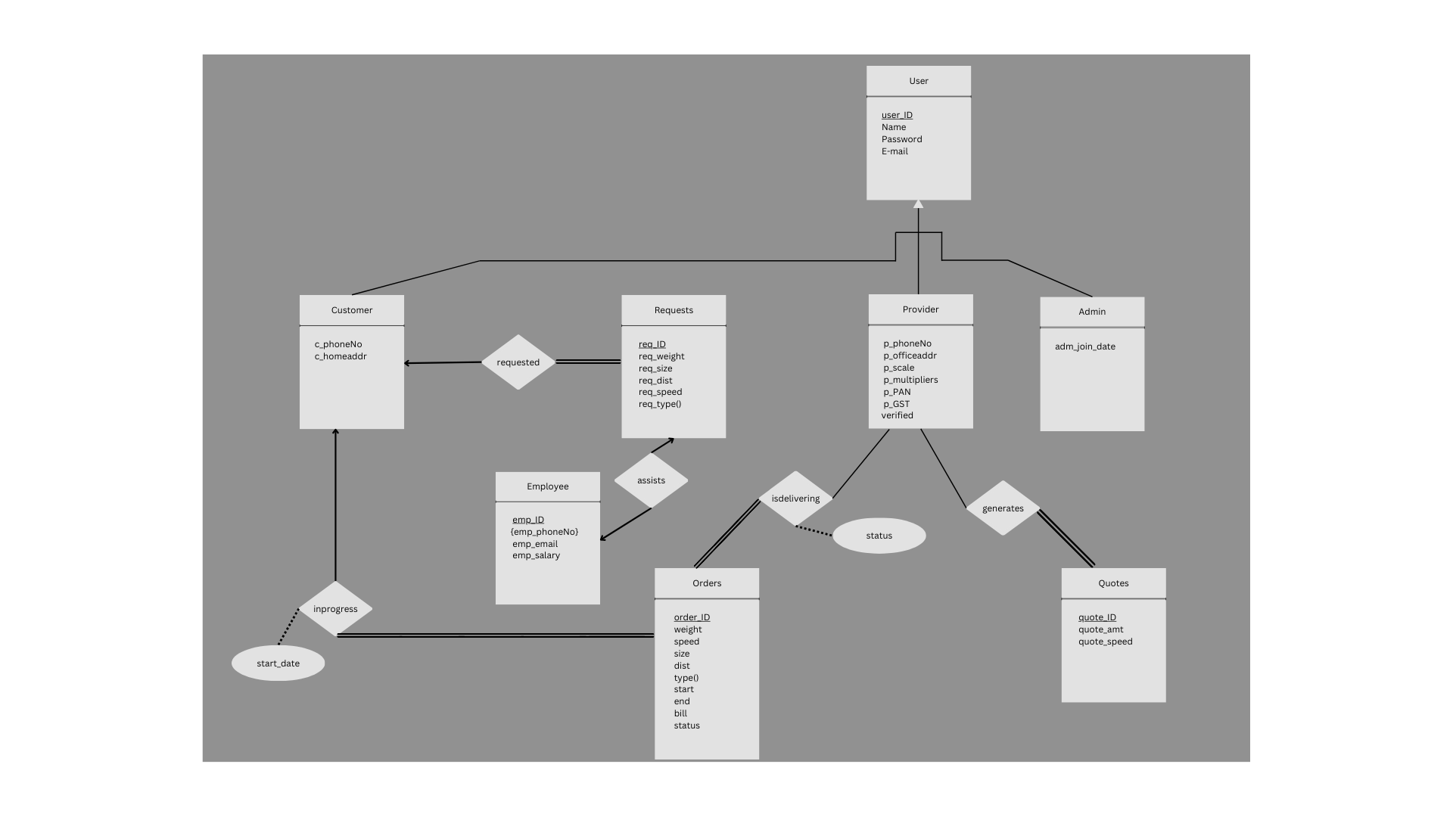Figure 1: ER Diagram for Go-VYA Cargo Management Service

**Reduced Schema**

**USER** (user_ID INT, name VARCHAR(50), password VARCHAR(16), email VARCHAR(50));

**CUSTOMER** (c_ID INT, c_homeaddr VARCHAR(255), c_phoneNo VARCHAR(15));

**PROVIDER** (p_ID INT, p_scale VARCHAR(50), p_officeaddr VARCHAR(255), p_phoneNo VARCHAR(15), p_multiplier FLOAT, p_PAN VARCHAR(20), p_GST VARCHAR(20),verified boolean);

**ADMIN** (adm_ID INT, adm_join_date DATE);

**REQUESTS** (req_ID INT, c_ID INT, req_weight FLOAT, req_size FLOAT, req_speed INT), req_dist FLOAT, req_type VARCHAR(50),start VARCHAR(50), end VARCHAR (50));

**QUOTES** (quote_ID INT, p_ID INT, quote_amt FLOAT, quote_speed VARCHAR(50),req_ID INT);

**ORDERS** (c_ID INT, p_ID INT, order_ID INT, weight FLOAT, size FLOAT, type VARCHAR(50), speed VARCHAR(50), start_date DATE, status VARCHAR(50), dist FLOAT,start VARCHAR(50), end VARCHAR (50),bill FLOAT);

**EMPLOYEE** (emp_ID INT, emp_email VARCHAR(50), emp_salary FLOAT,isAssisting INT);

**EMP_PHONENO** (emp_ID INT, emp_phoneNo VARCHAR(15));

**Schema Diagram**

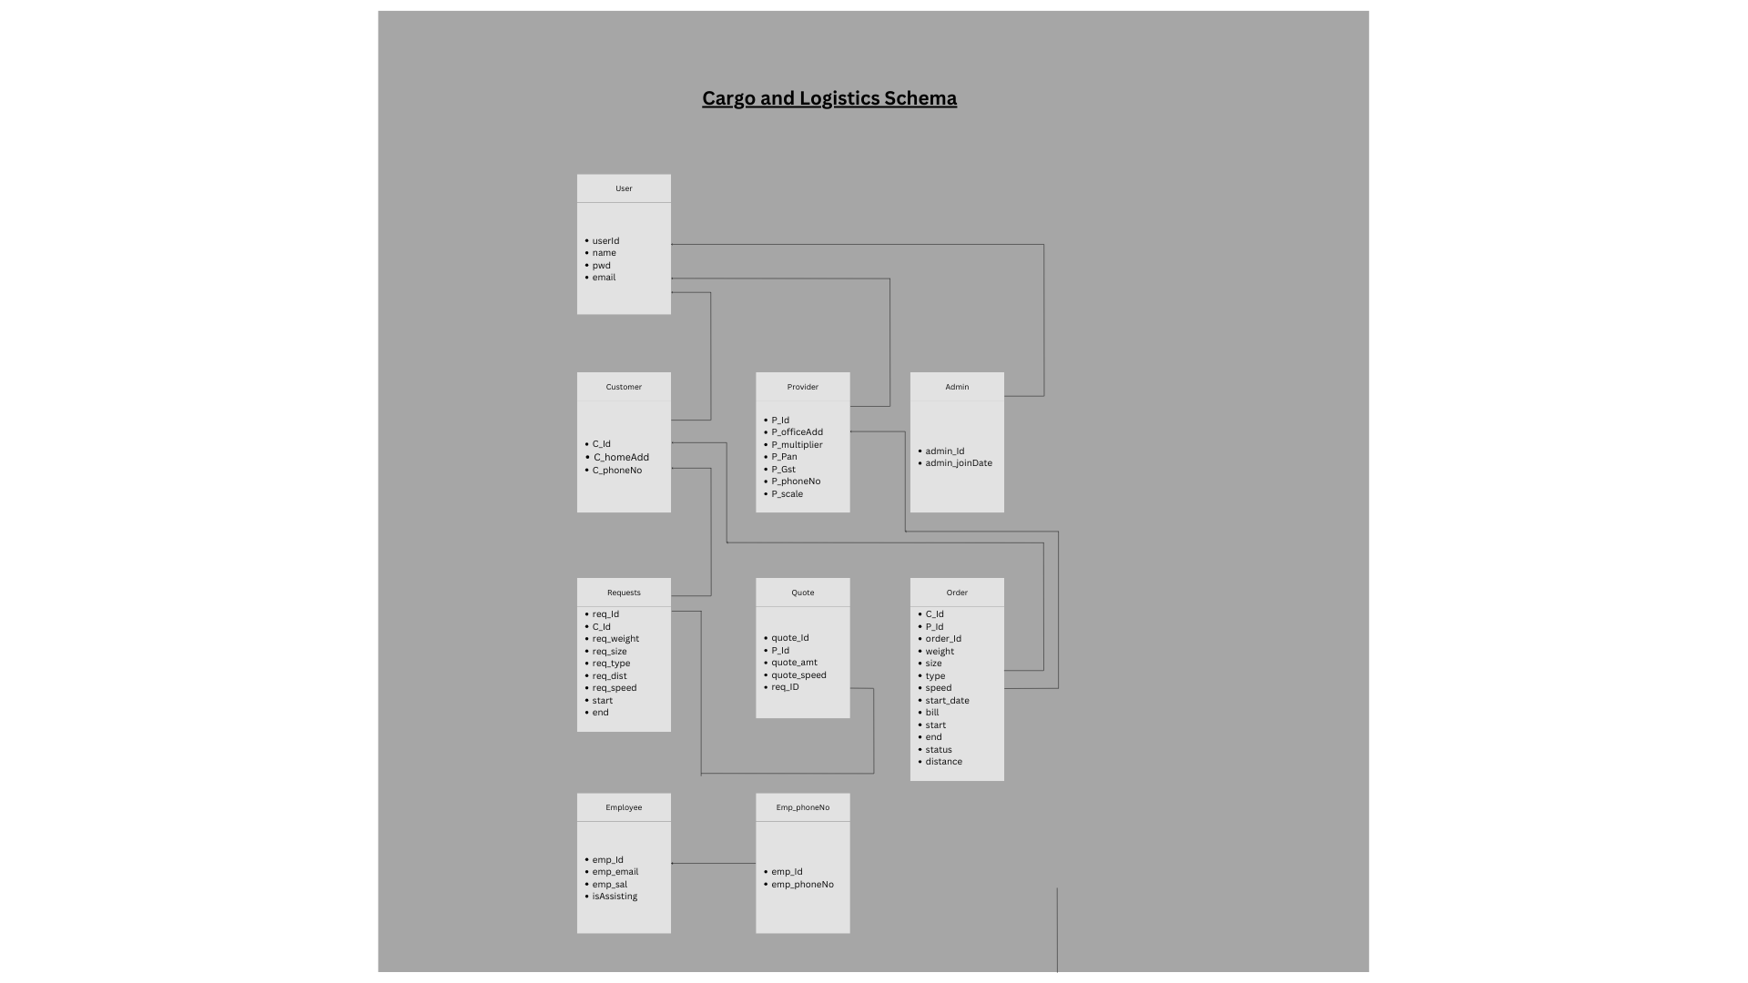Figure 2: Schema Diagram for Go-VYA Cargo Management Service

**Normalisation**

**Universal Relation** =

{name, user_ID, password, email, c_ID, c_homeaddr, c_phoneNo, p_ID, p_scale, p_officeaddr, p_phoneNo, p_multiplier, p_PAN, p_GST, adm_ID,verified, adm_join_date, req_ID, req_weight, req_size, req_speed, req_dist, req_type, order_ID,bill,start,status,end ,weight, size, type, speed, start_date, dist, quote_ID, quote_amt, quote_speed, emp_ID, emp_phoneNo, emp_email, emp_salary,isAssisting}

**Functional Dependencies**  
user_ID ➔ name, password, email

c_ID ➔ c_homeaddr, c_phoneNo

p_ID ➔ p_scale, p_officeaddr, p_phoneNo, p_multiplier, p_PAN, p_GST

adm_ID ➔ adm_join_date

req_ID ➔ req_weight, req_size, req_dist, req_speed, req_type

quote_ID ➔ quote_amt, quote_speed

order_ID➔ weight, speed, size, dist, type

emp_ID ➔ emp_email, emp_salary

order_ID,c_ID ➔start_date

order_ID,p_ID➔status

**Normalising to First Normal Form (1NF):**

*A relational schema R is in first normal form if the domains of all attributes if R are atomic, i.e it disallows composite attributes, multivalued attributes, and nested relations.*

*Thus removing emp_phoneNo from UniversalRelation and creating following relations.*

**R1** (name, user_ID, password, email, c_ID, c_homeaddr, c_phoneNo, p_ID, p_scale, p_officeaddr, p_phoneNo, p_multiplier, p_PAN, p_GST, adm_ID, adm_join_date, req_ID, req_weight, req_size, req_speed, req_dist, req_type, order_ID, weight, size, type, speed, start_date, status, dist, quote_ID, quote_amt, quote_speed, emp_ID, emp_email, emp_salary, verified,,bill,start,end)

**R2** (emp_ID, emp_phoneNo)

**Normalising to Second Normal Form (2NF):**

*2NF is based on the concept of Full Functional Dependency.*

*A relation schema R is in 2NF if it is in 1NF form and every non-prime attribute A in R is fully functionally dependent on the primary key of R.*

*In R1, we observe the existence of some partial functional dependencies. We see that the attributes are fully functionally dependent on the primary keys user_ID, c_ID, p_ID, adm_ID, req_ID, quote_ID, order_ID, and emp_ID respectively.So as to preserve the integrity of the second normal form we decompose R1 into the following relations.*

**R1_A** (user_ID, name, password, email);

**R1_B** (c_ID, c_homeaddr, c_phoneNo);

**R1_C** ( p_ID, p_scale, p_officeaddr, p_phoneNo, p_multiplier, p_PAN, p_GST,verified);

**R1_D** ( adm_ID, adm_join_date);

**R1_E** (req_ID, c_ID, req_weight, req_size, req_speed, req_dist, req_type,start,end);

**R1_F** (quote_ID, p_ID,quote_amt, quote_speed,req_ID,bill);

**R1_G** (order_ID,c_ID,p_ID, weight, size, type, speed, start_date, status, dist,bill,start,end)

**R1_H** (emp_ID, emp_email, emp_salary,isAssisting );

**R2** (emp_ID, emp_phoneNo);

**Normalising to Third Normal Form (3NF):**

*A relation is in the third normal form, if there is no transitive dependency for non-prime attributes as well as it is in the second normal form. A relation is in 3NF if at least one of the following conditions holds in every non-trivial functional dependency X –> Y.*

1. *X is a super key.*
2. *Y is a prime attribute (each element of Y is part of some candidate key).*

Since there are no transitive dependencies in any of the relations, all relations are already in Third Normal Form (3NF).

**Normalised Relational Schema in 3NF:**

**R1** (user_ID, name, password, email);

**R2** (c_ID, c_homeaddr, c_phoneNo);

**R3** ( p_ID, p_scale, p_officeaddr, p_phoneNo, p_multiplier, p_PAN, p_GST,verified);

**R4** ( adm_ID, adm_join_date);

**R5** (req_ID, c_ID, req_weight, req_size, req_speed, req_dist, req_type,start,end);

**R6** (quote_ID, p_ID,quote_amt, quote_speed,req_ID,bill);

**R7** (order_ID,c_ID,p_ID, weight, size, type, speed, start_date, status, dist,bill,start,end)

**R8** (emp_ID, emp_email, emp_salary,isAssisting );

**R9 (emp_ID, emp_email, emp_salary );**

**Chapter 5**

**Methodology**

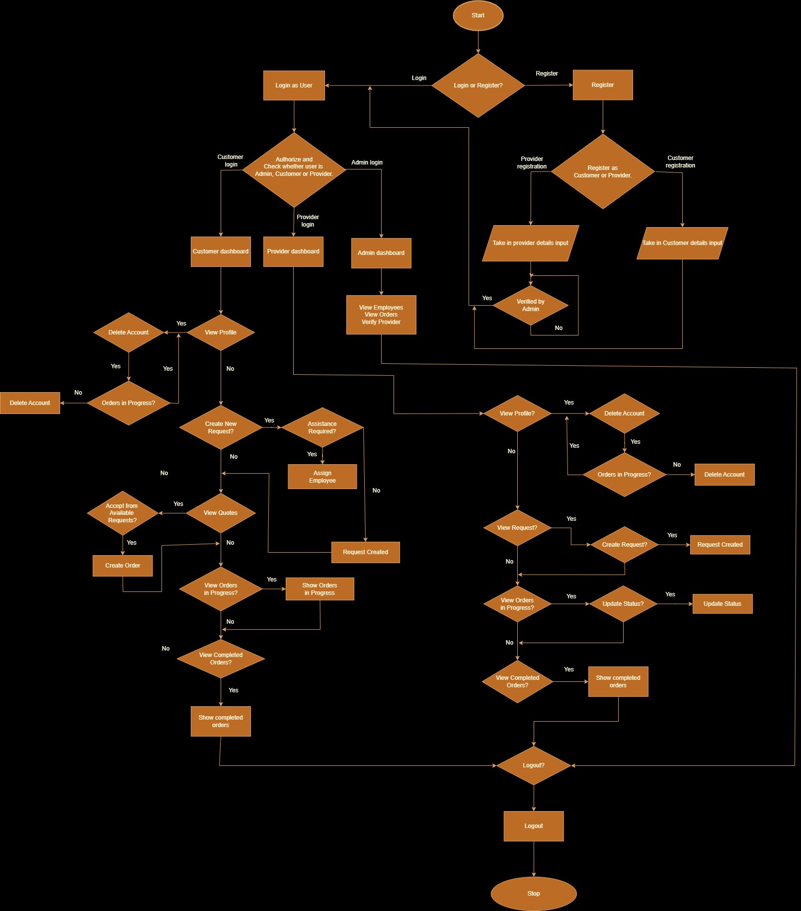

**5.1 Implementation Approach for GO-VYA:**

Implementing GO-VYA, the comprehensive cargo and logistics management system, parallels constructing a digital nexus where seamless interaction between customers and providers optimizes the shipping process. Initial consultations with stakeholders, including customers and providers, yield crucial insights into their needs and expectations from the platform. Much like drafting architectural plans before construction, thorough planning precedes implementation to ensure alignment with user requirements and industry standards.

The implementation process of GO-VYA unfolds in several phases:

Requirements Gathering: Extensive discussions with customers and providers lay the foundation for understanding their requirements and expectations from the platform. Insights gleaned from these interactions inform the design and functionality of GO-VYA, ensuring it meets the diverse needs of its users.

System Design: The design phase encompasses the creation of architectural blueprints, database schemas, and technological frameworks. Careful consideration is given to selecting programming languages, frameworks, and databases, prioritizing factors such as scalability, performance, and compatibility with existing infrastructure.

User Management: At the core of GO-VYA lies user management, ensuring secure access and appropriate privileges for different user roles. Role-based access control mechanisms are implemented to delineate the capabilities of customers, providers, and administrators, safeguarding sensitive data and maintaining system integrity.

Quoting and Order Management: Functionalities for quoting and order management are designed to streamline the shipping process. When a request is generated, GO-VYA categorizes the scale of the shipment as large, medium, or small based on parameters such as weight, size, and distance. Providers then generate quotes accordingly, taking into account the scale of the shipment and other factors. GO-VYA employs robust algorithms to suggest the best price for the user, considering various quotes and factors such as delivery time, cost, and service quality. Customers can compare quotes and select the most suitable option, ensuring transparency and cost-effectiveness in the shipping process. Orders are tracked in real-time, facilitating efficient management and communication between users.

User Interface Design: The user interface of GO-VYA is crafted for intuitive navigation, responsive design, and clear visual cues to enhance the user experience. Iterative usability testing ensures that the interface meets users' needs and preferences, fostering seamless interaction and task completion.

Testing and Quality Assurance: Rigorous testing, including unit testing, integration testing, and user acceptance testing, is conducted to identify and rectify bugs, ensure system compatibility,

and validate user workflows. Performance testing assesses the scalability and responsiveness of GO-VYA under various load conditions.

In conclusion, the successful implementation of GO-VYA requires a holistic approach encompassing requirements analysis, system design, development, testing, deployment, training, and ongoing support. By leveraging technology to streamline the logistics process, GO-VYA aims to enhance collaboration, efficiency, and transparency in the shipping industry.

**Chapter 6**

**Results**

**Brief Results of the App:**

1. **Increased Efficiency**: GO-VYA streamlined the quoting and order management process, resulting in faster response times and improved efficiency for both customers and providers.
2. **Cost Savings:** By suggesting optimal prices based on shipment parameters and facilitating transparent comparisons of quotes, GO-VYA helped users secure cost-effective shipping solutions, leading to potential savings on logistics expenses.
3. **Enhanced User Experience:** The intuitive user interface and real-time tracking capabilities of GO-VYA contributed to a positive user experience, fostering increased engagement and satisfaction among customers and providers.
4. **Improved Communication:** GO-VYA facilitated transparent communication between customers and providers, enabling seamless collaboration and coordination throughout the shipping process.
5. Increased Transparency: Through features such as provider ratings and real-time tracking, GO-VYA promoted transparency in transactions and operations, building trust and confidence among users.
6. Scalability and Reliability: The integration of React.js and Django ensured scalability and reliability of the platform, allowing GO-VYA to accommodate growing user demands while maintaining optimal performance.

Overall, the implementation of GO-VYA yielded tangible benefits in terms of efficiency, cost savings, user experience, communication, transparency, scalability, and reliability, positioning it as a valuable asset in the logistics industry.

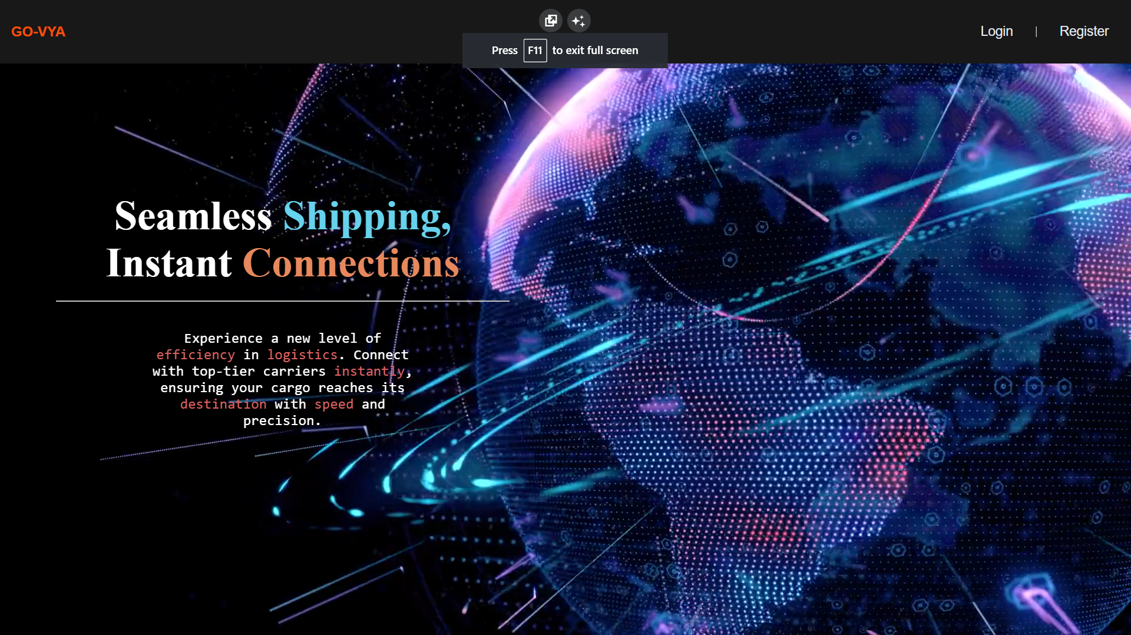Home page

New User Registration Page

Customer Registration

Provider Registration

Login Page

Wrong User ID or Password

Admin Portal

Verification of Provider Accounts

All Orders Page

Employee Details

Customer Dashboard

Customer Profile Page

New Request Creation

Asking Assistance from an Employee

Order in Progress Page

Viewing Previously Completed Orders

Provider Dashboard

Provider Profile Page

View Available Requests

Available Quotes to a Customer

View Available Requests

Updating Status of Orders by Provider

Unauthorized Access Page while to access resources without Permissions

# Chapter 7

**Conclusion and Future Works**

7.1 Conclusion:

The successful development and implementation of GO-VYA, a pioneering cargo and logistics management system, signify a paradigm shift in the industry. Through innovative features and meticulous planning, GO-VYA has revolutionized the way shipping processes are managed, offering unprecedented levels of transparency, efficiency, and cost-effectiveness.

Key innovations implemented in GO-VYA include its advanced quoting and order management functionalities, which streamline the shipping process and empower users to make informed decisions. By categorizing shipments based on scale and suggesting optimal prices, GO-VYA maximizes cost savings for customers while ensuring fair competition among providers.

Additionally, GO-VYA's user-centric design, incorporating intuitive interfaces and real-time tracking capabilities, sets a new standard for user experience in the logistics industry. Its robust security measures and role-based access control mechanisms ensure data integrity and user privacy, instilling trust and confidence among stakeholders.

In conclusion, GO-VYA represents a transformative leap forward in cargo and logistics management, driven by innovation, collaboration, and a commitment to excellence. As the industry continues to evolve, GO-VYA stands as a testament to the power of technology to address complex challenges and deliver tangible benefits to businesses and consumers alike.

7.2 Future Works:

1. Mobile Application Development: Expanding the accessibility of GO-VYA through mobile application development will enhance user convenience, allowing customers and providers to manage shipments and access platform features on-the-go. This initiative will cater to the increasing trend of mobile usage and provide a seamless experience across devices.
2. Consumer/Provider Ratings and Profiling Features: Implementing consumer and provider ratings, along with profiling features, will enrich the user experience on GO-VYA. By enabling users to rate and review their experiences with providers, GO-VYA can foster trust and accountability within the community. Profiling features will allow users to customize their preferences, leading to more personalized service recommendations.
3. CNN-Based Mapping of Customers to Providers: Utilizing Convolutional Neural Networks (CNNs) for mapping customers to providers based on various parameters such as location, shipment requirements, and provider capabilities can optimize matching efficiency on GO-VYA. This advanced mapping technique will enhance the accuracy and relevance of provider recommendations, improving user satisfaction and operational efficiency.
4. React + Django Integration for Scalability: Integrating React.js frontend with Django backend architecture will enhance scalability and performance capabilities of GO-VYA. This integration will leverage React's component-based architecture for building interactive user interfaces and Django's robust backend framework for handling complex business logic and data management. By leveraging the strengths of both technologies, GO-VYA can efficiently handle increasing user demands and scale its operations seamlessly.
5. Predictive Analytics for Demand Forecasting: Implementing predictive analytics algorithms for demand forecasting will enable GO-VYA to anticipate future shipping needs and trends. By analyzing historical data and market dynamics, GO-VYA can proactively adjust its services, pricing strategies, and resource allocation to meet anticipated demand, ensuring optimized operations and improved service quality.
6. Blockchain Integration for Enhanced Security and Transparency: Integrating blockchain technology into GO-VYA's architecture will enhance security and transparency in transactions and data management. By leveraging blockchain's decentralized ledger and cryptographic mechanisms, GO-VYA can ensure tamper-proof record-keeping, secure payment processing, and transparent tracking of shipments. This initiative will enhance trust among users and stakeholders and mitigate risks associated with data breaches and fraudulent activities.

**References**

**[**[1] Silberschatz, A., Korth, H. F., & Sudarshan, S. (2019). Database System Concepts. McGraw-Hill Education.

[2] Clark, N. (2019). SQL for Beginners: Learn SQL using MySQL and Database Design. Independently published.

[3] Ghiani, G., Laporte, G., & Musmanno, R. (2013). Introduction to Logistics Systems Management. John Wiley & Sons.

[4] Christopher, M. (2016). Logistics and Supply Chain Management. Pearson Education Limited.

[5] Grinberg, M. (2018). Flask Web Development: Developing Web Applications with Python. O'Reilly Media.

[6] Duckett, J. (2011). HTML and CSS: Design and Build Websites. Wiley.

[7] "Flask Documentation." Flask. [Online]. Available: https://flask.palletsprojects.com/en/2.1.x/. [Accessed: Apr. 21, 2024].

[8] "Mozilla Developer Network (MDN) Web Docs." MDN Web Docs. [Online]. Available: <https://developer.mozilla.org/en-US/docs/Web>. [Accessed: Apr. 21, 2024].